Victoria University, Semester 1;
Humanities PPSS: AEB3308;
Jesse Damjanovski: s4496296;
Lesson Plan: 3;
Date of Lesson: 11 June 2016;
Learning Area: History, Year 9;
Topic: Significant Events, Turning Points, and the Nature of War.

Learning Objective:
The learning objective for this lesson will be for students to understand the nature of warfare told from multiple perspectives. This will be achieved by students investigating a battle that occurred during the war, as well as reviewing literature and artwork from soldiers who fought on both sides.
Teaching Objective:
Being the third lesson out of five in this unit of work, I want to develop and improve my skills in relation to implementing assessment as learning. This involves ‘students reflecting on and monitoring their progress to inform their future learning and your teaching’ (Godinho 2013, p. 215). Know students have developed a body of work they can use that as data to interpret if they need to improve on certain areas. I can then use this to reflect on my own teaching, and address areas of improvement in future practice.
Links to the Curriculum:
Victorian Curriculum:
Humanities, History:
Levels 9 and 10:
Significant events, turning points of the war and the nature of warfare (VCHHK141)

Vocabulary:
- World War I;
- Battle of the Somme;
- Trench Warfare;
- Shellshock;
- Armistice.
Materials, Resources and Equipment:
- Excerpts from WWI literature;
- WWI paintings;
- Film Excerpt showing the brutality of WWI;
- The Great War YouTube Series;
- Student textbooks.

References:
- Cobb, H 2010, Paths of Glory, Penguin Books, London.
- Dix, O 1924, Shock Troops Advance under Gas, Etching, 19.3 x 28.8 cm, Drawing and Prints, Museum of Modern Art, New York.
- Godinho, S 2013, ‘Planning for practice: connecting pedagogy, assessment and curriculum’, in R. Churchill (ed.), Teaching: Making a Difference, John Wiley & Sons, Milton, QLD, pp. 210-249.
- Junger, E 2014, Strom of Steel, Penguin Books, London.
- Nolan, S 1942, Head of a Soldier, Enamel on Cardboard, 75.8 x 63.3 cm, National Gallery of Australia, Canberra.
- The Great War 2016, ‘Trench Warfare in World War 1’, video file, viewed 11 June 2016, <https://www.youtube.com/watch?v=P92guhd7d-8>.
- Victorian Curriculum 2016, the Humanities: History Curriculum F-10 Levels 9-10, Victorian Curriculum and Assessment Authority, viewed 9 June 2016, <http://victoriancurriculum.vcaa.vic.edu.au/the-humanities/history/curriculum/f-10#level=9-10>

Part 1: Sequence:
(1) Introducing the learning objective and outlining student expectations; (2) investigate one major battle of WWI, in this case the Somme; (3) Relate it to the nature of warfare; (4) explain how the war ended.

Part 2: Content:
- The Battle of the Somme;
- The nature of warfare: gas attacks, trench warfare, and shell-shock;
- Outline the key events that lead to the end of the war: Russia leaving; America entering; and the severe loses that Germany faced;
- Explain how the war ended: Armistice and the Treaty of Versailles;
- Analyse artwork and literature from soldiers who fought in WWI.

Part 3: Activity:
- The main activity for this lesson will be broken into three stages: presentation of a video during the micro-lecture, compare and contrasting artwork, and writing a reflection from a literary text.
- Students will watch a video clip from the YouTube Chanel, The Great War. This video explains the nature of trench warfare and the experiences soldiers endured. Link to the video: https://www.youtube.com/watch?v=P92guhd7d-8
- The second stage of the lesson will involve students to compare and contrast two artworks from artists from different sides. Students are to examine the character and message these works portray, and how they reflect the nature of warfare. These artworks can be found in the appendix below.
- For the last part of the lesson, students are required to write a reflection from one of two pieces of literature written by soldiers who fought on both sides. Students need to analyse the language of the text and how it relates to warfare.

Part 4: Time:
Double block running for 1 hour and 40 minutes (two 50 minute periods)
(1) 20 minute micro-lecture; (2) 35 minutes for compare and contrast; (4) 35 minutes for written reflection; (5) 10 minutes for wrap-up and conclusion

Evaluation and Reflection:
This lesson will allow students to demonstrate their writing and analysing skills; both very important for studying history. Furthermore, students will have the opportunity to improve on interpreting historical sources and evidence; which is listed as a key still to have in the Victorian Curriculum.

Appendix:
Entente Perspective: Head of a Soldier, Sidney Nolan:
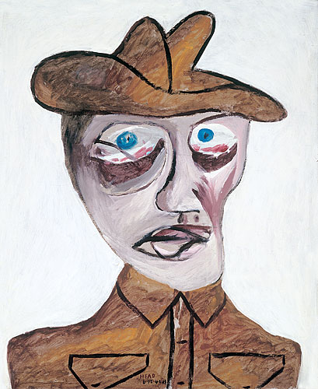

Alliance Perspective: Shock Troops Advance under Gas, Otto Dix:
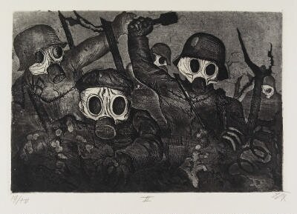

Entente Perspective: Paths of Glory, Humphry Cobb:
He saw the delicate blades of grass which the bodies of his comrades had fertilized; he saw the little shoots on the shell-shocked trees. He saw the smoke-puffs of shrapnel being blown about by light breezes. He saw birds making love in the wire that a short while before had been ringing with flying metal. He heard the pleasant sounds of larks up there, near the zenith of the trajectories. He smiled a little. There was something profoundly saddening about it. It all seemed so fragile and so absurd.
Alliance Perspective: Storm of Steel, Ernst Junger:
The villages we passed through on our way had the look of vast lunatic asylums. Whole companies were set to knocking or pulling down walls, or sitting on rooftops, uprooting the tiles. Trees were cut down, windows smashed; wherever you looked, clouds of smoke and dust rose from vast piles of debris. We saw men dashing about wearing suits and dresses left behind by the inhabitants, with top hats on their heads. With destructive cunning, they found the roof-trees of the houses, fixed ropes to them, and, with concerted shouts, pulled till they all came tumbling down. Others were swinging pile-driving hammers, and went around smashing everything that got in their way, from the flowerpots on the window-sills to whole ornate conservatories.
As far back as the Siegfried Line, every village was reduced to rubble, every tree chopped down, every road undermined, every well poisoned, every basement blown up or booby-trapped, every rail unscrewed, every telephone wire rolled up, everything burnable burned; in a word, we were turning the country that our advancing opponents would occupy into a wasteland.
As I say, the scenes were reminiscent of a madhouse, and the effect of them was similar: half funny, half repellent. They were also, we could see right away, bad for the men's morale and honour. Here, for the first time, I witnessed wanton destruction that I was later in life to see to excess; this is something that is unhealthily bound up with the economic thinking of our age, but it does more harm than good to the destroyer, and dishonours the soldier.

